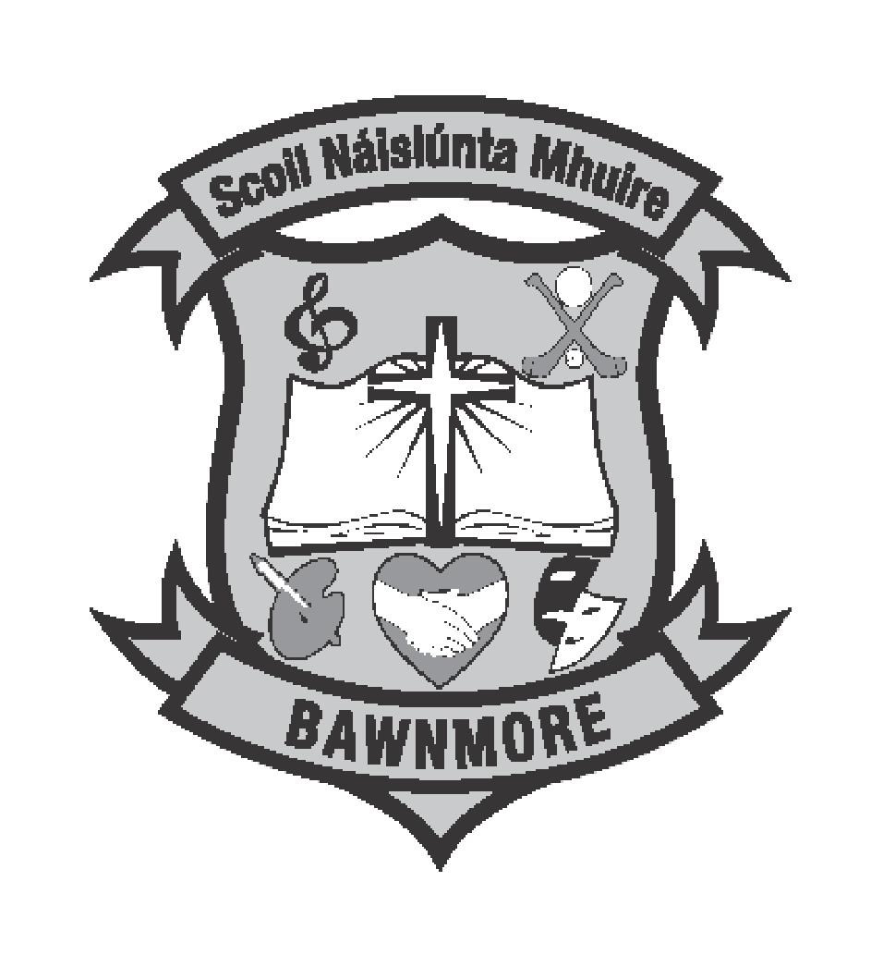

Scoil Náisiúnta Mhuire,
Bawnmore National School,
Claregalway,
Co.Galway.

Tel: 091 798600
bawnmorens@eircom.net
Roll No: 09069L

Scoil Náisiúnta Mhuire,

Bawnmore.
Relationships and Sexuality Education Policy
Introduction

Scoil Náisiúnta Mhuire, Bawnmore is a co-educational mainstream primary school catering for children from infants to sixth class. Scoil Náisiúnta Mhuire, Bawnmore is a Catholic school and therefore all policies developed are implemented in ways which are in keeping with the ethos of the school. It is our intention that everyone feels valued and our pupils are encouraged to develop their full potential in a caring and supportive environment. Relationships and Sexuality Education (R.S.E.) encompasses the acquisition of knowledge and understanding, and the development of attitudes, beliefs and values about relationships, sexual identity and intimacy. In Scoil Náisiúnta Mhuire, Bawnmore we seek to promote the overall development of the child which involves the integration of Relationships and Sexuality into personal understanding, growth and development.

Development of this policy
Parents will be encouraged to become familiar with the content if the R.S.E policy and to play a meaningful role in the implementation of the R.S.E. programme. Consultations took place with staff and Board of Management in the writing of this policy.

Definition of RSE
Relationships and Sexuality Education seeks to provide children with opportunities to acquire knowledge and understanding of relationships and human sexuality, through processes which will enable them to form values and establish behaviours within a moral, spiritual and social framework. RSE aims to help children learn, at home and in school, about their own development and about their friendships and relationships with others. This work will be based on developing a good self-image, promoting respect for themselves and others and providing them with appropriate information. In particular, it addresses the meaning of human sexuality, relationships, growth and development, relevant to personal and social skills.

Aims of our RSE programme
- To enhance the personal development, self-esteem and well-being of each child.
- To help children develop healthy friendships and relationships.
- To foster an understanding of, and a healthy attitude to, human sexuality and relationships in a moral, spiritual and social framework
- To enable the child to acquire an understanding of, and respect for, human love, sexual intercourse and reproduction
- To develop and promote in the child a sense of wonder and awe at the process of birth and new life
- To enable the child to be comfortable with the sexuality of oneself and others while growing and developing
Broad Objectives
The RSE education curriculum should enable the child to (in conjunction with the SPHE curriculum)

- Acquire and develop knowledge and understanding of self

- Develop an appreciation of the dignity, uniqueness and wellbeing of others

- Develop a positive sense of self-awareness, self-esteem, and self-worth

- Understand the nature, growth and development of relationships within families, in friendships and wider contexts
- Develop an awareness of differing family patterns

- Come to value family life and appreciate the responsibilities of parenthood

- Develop strategies to make decisions, solve problems and implement actions in various personal, social and health contexts
- Become aware of the variety of ways in which individuals grow and change and understand that their developing sexuality is an important aspect of self-identity
- Develop personal skills which help to establish and sustain healthy personal relationships

- Develop coping strategies to protect self and others from various forms of abuse

- Acquire and improve skills of communication and social interaction

- Acquire the use of appropriate vocabulary to discuss feelings, sexuality, growth and development
- Develop a critical understanding of external influences on lifestyles and decision making.

We support the aims on which RSE is modelled. We encourage good behaviour, open communication, understanding and tolerance of differences, and respect for self and others. We recognise that both pupils and staff have rights and responsibilities in our school. A sense of responsibility is fostered and attention is paid to the wellbeing of all of the members of the school community.

Relationship of RSE to Social, Personal and Health Education
In Scoil Náisiúnta Mhuire, Bawnmore, RSE will be taught in the context of Social, Personal and Health Education. SPHE is a subject in the primary school curriculum. SPHE contributes to developing the work of the school in promoting the health and well-being of children and young people. SPHE is taught from Junior Infants to Sixth class and is formally timetabled.
RSE will be facilitated in the following ways within our school:
- In the context of a positive school climate and atmosphere
- As part of timetabled S.P.H.E.
- On an integrated, cross-curricular basis
The SPHE Curriculum is a spiral curriculum. This involves revisiting key topics in a developmental manner every two years. Within this framework the RSE programme will be explored with children bi-annually during their primary school years. All content objectives will be taught by the time the children leave 6thclass. All issues will be discussed with sensitivity, professionalism and awareness of the varying levels of development within a class.

Possible sensitive issues such as naming the body parts and sexual intercourse will be covered within the strand units “Taking care of my body,” “Growing and changing” and “Safety and Protection” See sensitive content to be covered at each class level in the Terminology table attached.

Management and Organisation of RSE

Proposed Timeline for teaching of S.P.H.E./RSE Programme

S.P.H.E. Plan
 | YEAR 1 | YEAR 2
Sept/Oct | Self-identity (Myself) | Myself and my family (Myself and others)
Oct/Nov | Stay Safe Programme | Stay Safe Programme
Dec/Jan | Making decisions (Myself)  Growing and Changing (Myself) Prep  Taking care of my body (Myself) Prep | Growing and Changing (Myself)  Taking care of my body (Myself)
Feb/Mar | RSE Sensitive issues | RSE Sensitive issues
Apr/May | My friends and other people (Myself and others) | Relating to others (Myself and others)
Jun | Media education (Myself and the wider world) | Developing citizenship (Myself and the wider world)

Multi-class situation
In our school, which is a multi-class situation there are children of different class levels and abilities in each room. Should information be inappropriate for the younger age group, we will withdraw them to another teacher’s class.

Co-educational education
Ours is a co-educational school
- We will teach the boys and girls together.

Terminology
The acquisition of appropriate language in RSE is crucially important to enable children to communicate confidently about themselves, their sexuality and their relationships (Interim Guidelines, p53). Not being familiar with the biological terms for the body can put children at a disadvantage. (DES Resource Materials for Education and Sexuality Education, Jnr./Snr. Infants, pp.148 -149). See also Going Forward Together p.17

We will give children the correct and appropriate language as outlined in the RSE materials.

Sexual Orientation will be discussed only if the children ask questions about the topic or if children are using the word ‘gay’ in a negative fashion. It is better not to ignore the practice in the hope that it will go away. The same would apply for any instance of bullying as per the Stay Safe Programme.
In this case the children (depending on the context and the age group of the children, will be asked by the teacher what they meant by the word ‘gay’ to ascertain the children’s understanding of the term.
The teacher’s response will be along the lines of “The majority of people are attracted to people of the opposite sex. This is called being heterosexual. Some people are attracted to people of the same sex. This is called being homosexual or gay. God created us all and loves us all equally.”
Homophobic and identity based insults should be treated in exactly the same way as racist or other insults-the teacher will calmly explain to the child that such insults are hurtful to the other person and are not acceptable. The teacher will refer to the Stay Safe Programme.

Assessment

Scoil Náisiúnta Mhuire, Bawnmore will employ the following methods for assessment in SPHE/RSE:
- Observation and questions to assess the pupils engagement and interest
- Use of teacher-designed tasks such as worksheet, quizzes or games
- Use of reflection or learning log

Questions
In our school, teachers may use a variety of methodologies to create a safe, open space where pupils feel comfortable to ask RSE related questions
Question Box
For older pupils a “question box “ is one methodology that may be used as part of the formal RSE lessons. Teachers can follow up on the written questions at a later date, thus allowing time to prepare suitable answers, consult with colleagues/RSE policy to formulate an appropriate response.
During the delivery of each RSE lesson, pupils can be encouraged to place their questions in a box. These questions can be reviewed and the following may be taken into account:
- All pupils are encouraged to write on the question sheet. If they don’t have a question, ask them to write something interesting they learned in the lesson
- Questions arising from lesson content will be answered in an age appropriate manner
- The teacher cannot answer questions that do not relate to the particular curriculum objectives for the class.
- Pupils will be informed if a question/issue is not on the curriculum and they will be advised to talk with their parents/guardians/carers
- Teachers may exercise discretion to contact parents if a need arises
- No personal questions will be answered and children will be reminded not to share inappropriate personal information about their families or others

Open Form Questions
Teachers give pupils an opportunity to ask questions at various times throughout the RSE lesson. Questions will be answered in an age and developmentally appropriate way. Children will be made aware that the class teacher may not be able to answer their question and they will be directed to ask an adult they trust t home.

Possible responses
- I’ll do my best to answer your question but I may not be able to answer all of them
- That’s something you’ll learn about when you get older
- Is that something you could talk to your parents/guardians/family about?
- We agreed that we wouldn’t ask anyone any personal questions..
- Somebody asked a question and the language that was used was slang language. I think what they meant to ask was ……..

Differentiation
The age and stage of development in a class can vary widely and strategies for differentiation can support gradual and appropriate learning. In Scoil Náisiúnta Mhuire, Bawnmore use assessment and professional judgement to differentiate the curricular objectives and content to best suit the needs of all pupils.

Adaptations to the way in which the content is delivered will be made for children with special and additional needs. Both consultation with parents/guardians/carers in adavance of lessons and the anticipation of the pupil’s needs will be central to ensuring learning is meaningful. This may be reflected in the student’s support file.

SEN and Special Education Support
The SEN teacher and/or the Special Class teacher will if necessary
- Provide opportunities for interacting and working with other students in small groups of 1:1
- Ensure that the language used is pitched at the pupil’s level of understanding. Some children may be pre-taught language or concepts in preparation of whole class work
- Create a learning environment through the use of concrete, and where possible everyday materials and by displaying word lists and laminated charts with pictures
- Employ active learning methodologies
- Organize relevant and suitable resources to support the pupil’s level of understanding

Privacy
Everyone has a right to privacy (see Universal Declaration of Human Rights and UN Declaration on the Rights of the Child). Teachers will not answer personal questions about themselves nor require the child to give information of a personal nature that they do not wish to share.

Parents’/Guardians’ roles
- In SPHE and RSE parents are acknowledged as the primary educators of their children and the school will work in a supportive role.
- On enrolment parents will be provided with an overview of the SPHE/RSE programme and the list of possible sensitive issues.
- An outline of the lessons /sensitive issues will be available on request to parents before they are taught, so that they can prepare the child before it is dealt with in school, if they so wish.
- Since RSE is an obligatory requirement of the Department of Education and Science, it should be inclusive. We actively promote the implementation of RSE and strongly discourage
withdrawal. The school will, however, take account of parental concerns and a parent's right to withdraw a pupil from themes pertaining to sensitive issues will be honoured on the understanding that the parent(s)/guardian(s) is taking full responsibility for this aspect of education themselves. The parent(s) /guardian(s) will need to inform the school in writing of this decision.

Confidentiality
Scoil Náisiúnta Mhuire, Bawnmore, follows the Child Protection Procedures for Primary and Post Primary Schools 2017.
If a child is withdrawn from specific RSE lessons the school cannot guarantee that the withdrawn child will not hear the information from another source.
Parents are invited to share any changes in circumstances with the school as necessary e.g. changes in family structure etc. For the welfare of some children, this information may be important for a teacher to know prior to engaging in specific topics on family/relationships etc.

Teachers’ roles
- Each class teacher will teach the SPHE programme including the sensitive issues
- A teachers’ right to opt out from teaching the sensitive issues will be honoured. Provision will be made for these issues to be taught by a colleague.
- An external professional can be employed to support the teaching of the sensitive issues in 6th class. The class teacher or another member of staff will be present.

RSE policy and other curricular areas
Our policy in R.S.E. will also inform the teaching of the Strand “Living Things” in Science.

Sources and Resources:
- We will use the RSE and the Stay Safe programmes and other resources (suitable DVD e.g. Busy Bodies) that are deemed suitable
- We may also invite other visitors such as a mother, father and new baby when teaching certain aspects. These adults may be invited to talk and be questioned by the pupils.

Provision for ongoing support, development and review

The Board of Management supports and fosters the development of a R.S.E school policy. The programme of work will be reviewed at regular intervals by teachers. The B.O.M. will ensure access to in-career development opportunities for teachers and the policy committee in R.S.E. The policy and programme will be reviewed after the first year and every four years thereafter. All partners will be informed of any amendments necessary after such a review. R.S.E. resources will also be reviewed to ensure they are kept up to date.

Ratification and Communication
This school plan for RSE was ratified by the Board of Management of Scoil Náisiúnta Mhuire, Bawnmore in September 2022.

Resources

In our school our staff may consult any of the following teaching resources when teaching RSE in addition to the DE Relationships and Sexuality Education Programme.
- PDST Health and Wellbeing RSE
- NCCA SPHE/RSE Toolkit
- DE Walk Tall manuals
- Making the Links and Beyond
- Stay Safe programme
- Walk Tall programme
- Anatomical dolls
- HSE publications (www.healthpromotions.ie)
- Busy Bodies Booklet/Video/Workbook (PDST)
- INTO - Different Families, Same Love poster
- INTO – Different Families Same Love Lesson ideas
- INTO – Different Families Same Love presentation JI-2nd
- INTO – Different Families Same Love presentation 3rd-6th
- RESPECT guidelines
- Gender Equality Matters (GEM)
- All Together Now
- PDST Education and Transgender information
- Exploring Homophobia and Transphobia in Primary Schools in Ireland. (2016)
- RSE related educational websites

Classroom resources:
- The Great Big Book of Homes
- It’s Okay to be Different
- Red – A Crayons Story
- What’s happening to Tom?
- Things Ellie likes
SEN
- Healthy Body Resources – Van Der Bilt
- Taking Care of Myself Mary Worbel
- NCSE website
- www.middletownautism.com
- www.sexualwellbeing.ie

Dear Parent/Guardian,

Relationships and Sexuality education is an integral part of the S. P. H. E. programme. The sensitive elements of the Relationships and Sexuality education are covered under the strand units, ‘Growing and Changing’ and ‘Taking Care of my Body’. We will be completing these strand units with all class levels in the forthcoming weeks. These lessons can be viewed at : https://www.pdst.ie/primary/health-wellbeing/RSE

Our school RSE policy is available to view on our school website: https://www.bawnmorens.ie/ It outlines our agreed approach to achieve the objectives of the aforementioned strand units.

Social, Personal and Health Education Curriculum (NCCA 1999)
Infant – 2nd Class  Strand unit – Growing and Changing  - As I grow I change  - New Life  - Feelings and emotions  Strand unit – Taking care of my body  - Knowing about my body  - Food and nutrition  - Making decisions | 3rd Class – 6th Class  Strand unit – Growing and Changing  - As I grow I change  - Birth and new Life  - Feelings and emotions  Strand unit – Taking care of my body  - Knowing about my body  - Food and nutrition  - Health and wellbeing
* Please see the attached document for further information.

As you are the primary educators of your children, we recognise the right of any parent/guardian who so wishes to request that his/her son/daughter should not participate in the programme. The school will respect this choice. Where students are withdrawn from RSE, the school cannot take responsibility for any versions of class content passed on to them by other students. Any Parent/Guardian who wishes to withdraw his/her son/daughter must contact the Principal to make their wishes known. This request should be made in writing to the Principal before Feb 27th^{t} in order to allow for the provision of supervision for these students; otherwise the student will take part in the RSE classes. Please feel free to contact the school to discuss this matter.

Yours sincerely,

Caoilfhionn Casey

